System modeling is a fundamental process based on developing graphical abstract models of a system, to help clarify the functionalities of the existing system, showcase a variety of perspectives of this system, and used for discussing strengths or weaknesses or lead to creating new requirements and enhancing the system overall.
In order to fulfill the system modeling process, with each model presenting a different perspective of a system (user interactions, external interactions, structural perspective and general behavioral one).
Since our software is a web based system, not having to deal with huge hardware or complex external systems, hence the simplicity and straight forwardness of the UML diagrams used.
Here are the ones we have implemented in our system modeling process:

UML Activity Diagram
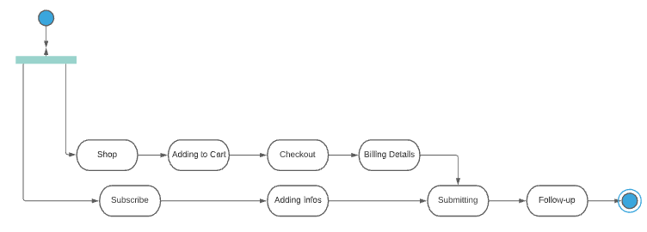

This diagram shows the activities involved in a process or in data processing.

UML Class Diagram
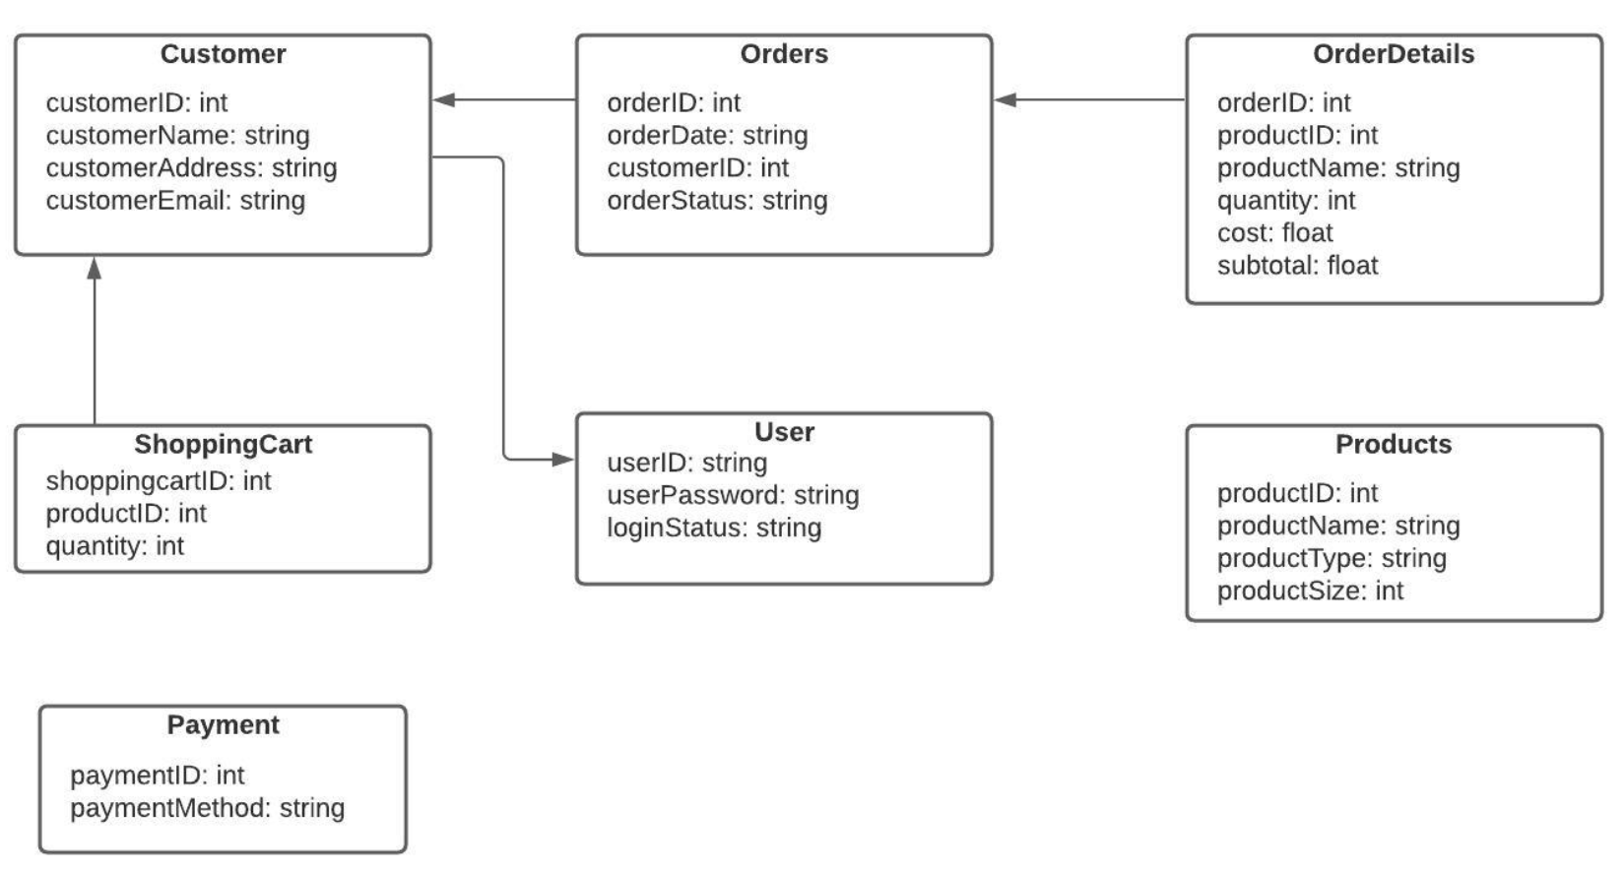

This diagram shows the object classes in the system and the associations between these classes.

UML State Diagram
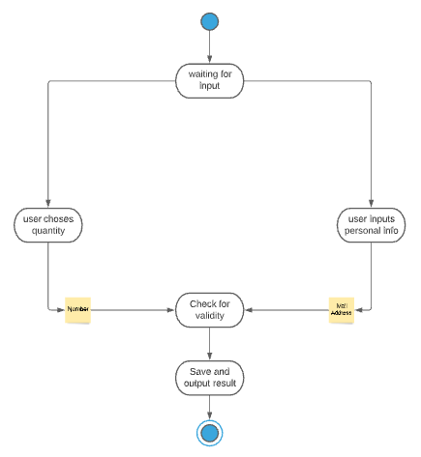

This diagram shows how the system reacts to internal and external possible events.

UML Use Case Diagram
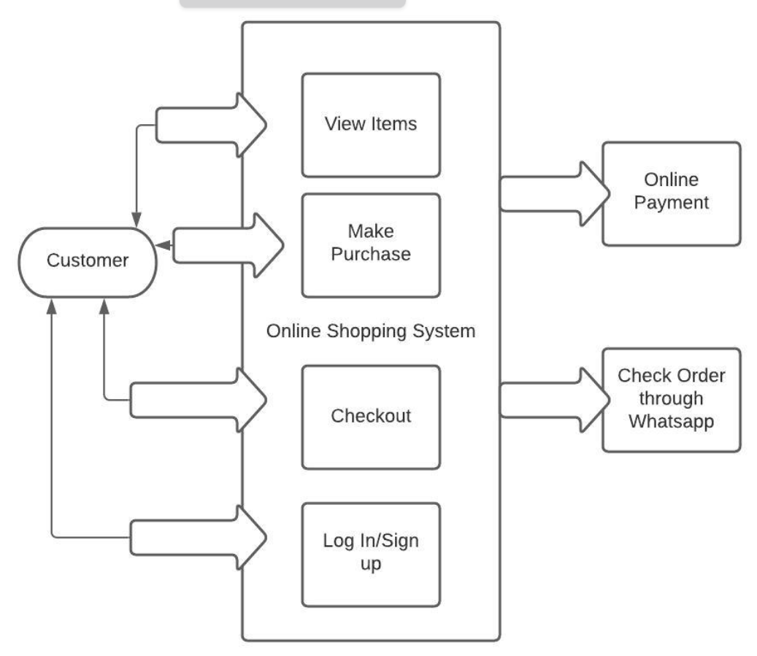

This diagram shows the interactions that may occur between a system and its environment.
(Alternatively a sequence diagram might be used to serve the same purpose)

